Managing Change

‘Change is the only constant’
Alvin Toffler

Change;
- It's a noun: "Change management is key to the project."
- It's a verb: "We really need to change manage that process."
- It's an adjective: "My change management skills are improving."
- It's an expletive: "Change management!"
Change is all around us all the time! It is how we react to the change that matters, and how we manage it determines whether it is perceived as a positive or is detrimental to your organisation.

Planning change
Change needs strong leadership, with a clear vision of the direction of travel. Communication is key. The team leader/manager usually acts as a channel for information from other parts of the organisation to their team. It is vital that all this information is passed on, as clearly as possible, and that you check it has been understood. Much damage can be done by managers who presume their staff don’t need to know some things and just need telling what to do or they assume staff already know and understand why the change is happening. The reasons for this openness are explored later, but honesty is always the best policy, and prevents misunderstandings and misinformation spreading through the workforce. Difficulties, being well-defined and more limited situations, mainly involve hard complexity. Given a particular view of the matter, what is the best that can be done? Unfortunate circumstances on the other hand are ill-defined; they include large measures of both hard and soft complexity. Of course, this may not be obvious at first and some or all of those involved may fail to recognise the soft complexity: they may initially resent alternative viewpoints, perhaps seeing them as misguided or even wilful attempts to confuse the ‘real’ issue.
Note three difficulties and two unfortunate circumstances (if possible) you have faced at work or alternatively in your private life. (If you can work in groups to do this so much the better). Using some of these examples think about how difficulties differ from unfortunate circumstances.
Difficulties.

1………………………………………………………………………………………………………………………………

………………………………………………………………………………………………………………………………..

2.……………………………………………………………………………………………………………………………..

………………………………………………………………………………………………………………………………..

3.……………………………………………………………………………………………………………………………..

………………………………………………………………………………………………………………………………..

Unfortunate circumstances.

1.……………………………………………………………………………………………………………………………

………………………………………………………………………………………………………………………………..

2. ……………………………………………………………………………………………………………………………

………………………………………………………………………………………………………………………………..

Changes can be defined as hard- or soft changes definition

There is a test called the TROPICS test which helps to define the situation.

TEST | HARD | SOFT
Timescales | Clearly defined, short to medium term | Difficult to define, medium to longer term
Resources | Clearly defined | Unclear
Objectives | Clearly defined and stated | Subjective and ambiguous
Perception | The problem is perceived in the same way by all | The problem is seen differently by different groups, hence possible conflict of interest
Interest | Interest in the problem known to be limited to a defined group | Interest in the problem is widespread or ill defined
Control | Control of the problem can be kept to a managing group | Control of the problem is shared because of the influence of others
Source | The source of the problem originates within the organisation | The source of the problem is external to the organisation

After McCalman and Paton (1992) Change Management, a guide to effective implementation
Those situations which can be classified as hard tend to be more readily and easily managed; the objectives and boundaries are clear. Soft changes are not so clear cut; there is a requirement to involve more people (possibly the whole organisation), in the preparation and implementation of change, which takes time (sometimes a good deal of it), to make real progress.

Take a couple of the examples you thought of in the first part of the activity and apply the TROPICS test.
When you have done this for each example, make a judgment as to whether your example is, overall, a hard or a soft problem/change situation, and explain why.
Difficulty/circumstances | Hard or Soft? | Why?

It might be that you as a leader are not enthusiastic about the change, but that should only be communicated upwards. If the change still must go ahead then you must be the one to motivate your team. Don’t moan. You can be honest but be positive. Furthermore, if you can be enthusiastic while still being honest that will really help your team engage. Celebrate small wins and gains. Not much will be achieved with a dispirited team. You must be a good negotiator throughout any change process, and you will invariably need to be innovative in finding ways around the inevitable problems change throws up. It is extremely important that you understand the organisation’s existing culture – its values, its ways of doing things and what’s the reason behind the change is necessary– to be able to implement it successfully, even if the change is intended to modify that culture.
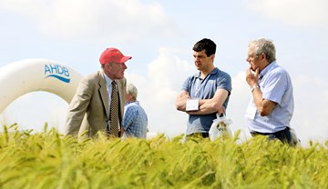
What qualities do you think you, as a leader, need to effectively lead a change management programme? List 5 and say why you think they are important.

1……………………………………………………………………………………………………………………

……………………………………………………………………………………………………………………

2……………………………………………………………………………………………………………………

……………………………………………………………………………………………………………………

3……………………………………………………………………………………………………………………

……………………………………………………………………………………………………………………

4……………………………………………………………………………………………………………………

……………………………………………………………………………………………………………………

5……………………………………………………………………………………………………………………

……………………………………………………………………………………………………………………

Remember it is not just your teams who might be affected by the change, other Stakeholders might be too. These might include.
- Banks
- Suppliers
- Contractors
- Customers/Processors
- The local community

Who else might you need to consider?

1………………………………………………………………………………………………………………………….

2……………………………………………………………………………………………………………………………

3………………………………………………………………………………………………………………………….

Choose three stakeholders and think about what effect change might have on them…

Stakeholder | Effect

As a Leader you must understand -
- The process of change
- What people need or want in a time of change
- How to support people through change.
There are two main types of change,
- From external forces requiring change e.g., your customers
- ‘Planned change’ where there is opportunity to plan, implement and control the change.
These 2 may overlap.
Kotter’s Change Management theory says there are 8 stages which must be achieved to successfully facilitate change.
Stage 1: Establish a sense of urgency
- Be clear on the competitive advantage change could give you;
- communicate this effectively to all involved
- There are no crises, only an imminent fear of failure
- The deadline drives the sense of urgency
Stage 2: Create a guiding coalition
- Have a Change management team (s)
- Involve people from all levels of the Organisation
- These become your ambassadors for change
Stage 3: Develop a vision and strategy
- Be very clear where you are going
- Plan how you will get there
- Work with people across the Organisation, from all departments and at all levels
- Plan several achievable milestones
Stage 4: Communicate, Communicate, Communicate
- Communicate as much as possible
- Have team briefings, 1-1’s where necessary (See example Onetoone.indd (windows.net)
- Remember that in the absence of fact, the grapevine takes over
- Communicate with people not directly involved too
Stage 5: Empower broad based action
- The biggest challenge is creating processes
- Empower staff to implement them having discussed them
- Encourage initiative taking and praise results
Stage 6: Generate short term wins
- Plan some achievable short-term milestones
- Publicise their success
- Praise everyone involved
- Build on these
Stage 7: Consolidate gains to produce more change
- Build on successes to produce more successes
- Ongoing Communication re-enforces the message
- Be positive about changes but acknowledge difficulties
Stage 8: Anchoring new approaches in the culture
- Hopefully the new approach will make life easier for key staff so it will become routine
- Change should pre-empt an upwardly beneficial improvement cycle.
- Messages must be re-enforced or old ways will return

Your team, or indeed your initial reaction to the change may not be entirely positive and there are series of stages that will need to be gone through before acceptance is reached. People go through these stages at different rates but think of it in terms of a dead tractor battery!
The Dead Tractor Battery.
Its winter and a cold morning. Its dark outside with a crisp frost under foot. You're running late, you open the tractor door, place the key in the ignition and turn it on. You hear nothing; the battery is dead. What happens next neatly demonstrates transition phases:
- Denial - What's the first thing you do? You try to start it again! And again. You may check to make sure the radio, heater, lights, etc. are off and then..., try again.
- Anger - !$%&*@~$! tractor!, I should have junked you years ago. Do you slam your hand on the steering wheel? Who left the (*& lights on?
- Bargaining - (realizing that you're going to be running even later), Oh please tractor, if you will just start one more time I promise I'll buy you a brand new battery, get you serviced, new tyres, clean you, and keep you in perfect working condition.
- Depression - Oh Dear, what am I going to do. It’s never going to start. I give up. My job is at risk, and I don't really care anymore. What's the use?
- Acceptance - Ok. It's dead. Guess I better call the dealer later to order a new battery and use the tractor instead. Time to get on with things; I'll deal with this later.
Tuckman's model explains that as the team develops maturity and ability, relationships establish, and the leader changes leadership style. Beginning with a directing style, moving through coaching, then participating and finishing with delegation, at which point they are almost detached. At this point, the team may produce a successor leader and the previous leader can move on to develop a new team.
This simple overview of the Tuckman 'Forming, Storming, Norming, Performing' model offers a simple way to understand how groups develop. Tuckman's model is especially helpful in training people on group work, thus enabling groups to fulfil their full potential.
https://www.businessballs.com/team-management/tuckman-forming-storming-norming-performing-model/
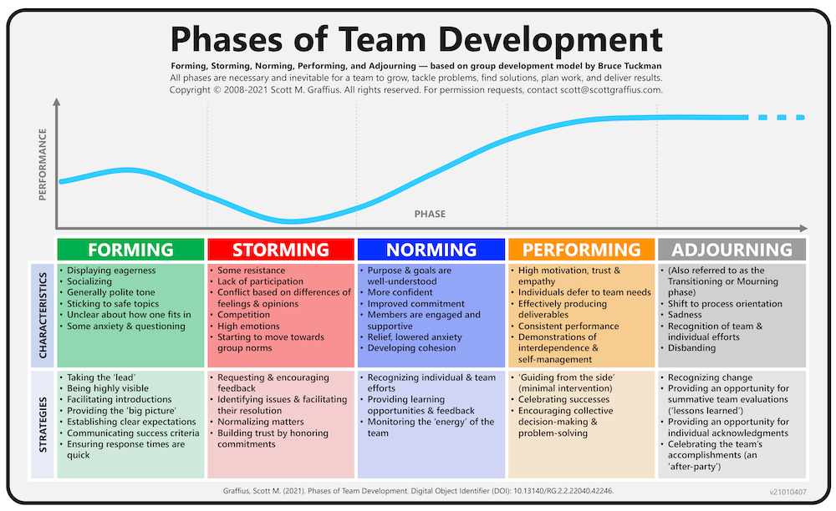
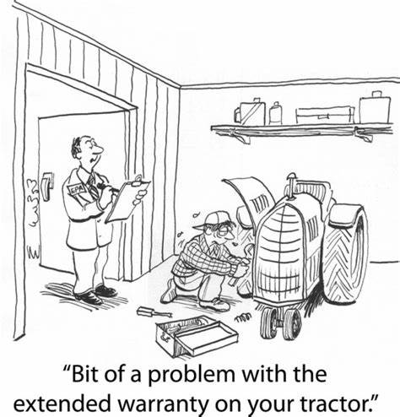
Farmer cartoon Stock Photos, Royalty Free Farmer cartoon Images | Depositphotos
How will change affect the team/how I need to work?
What is the Organisations’ message about the change?
……………………………………………………………………………………………………………………..

……………………………………………………………………………………………………………………..

……………………………………………………………………………………………………………………..

List three ways the change could be challenging for the team (or yourself??)
1……………………………………………………………………………………………………………………..

2…………………………………………………………………………………………………………………….

3…………………………………………………………………………………………………………………….

List three ways this could benefit the team (or yourself?)
1.……………………………………………………………………………………………………………………..

2……………………………………………………………………………………………………………………..

3……………………………………………………………………………………………………………………..

Given what I know about the team members how am I expecting them to react?
……………………………………………………………………………………………………………………..

……………………………………………………………………………………………………………………..

……………………………………………………………………………………………………………………..

……………………………………………………………………………………………………………………..

Crisis Management
Using crisis management techniques when implementing change can be useful – often crises that might not have been expected arise during a period of change. Crisis management involves fast decision making, clear public relations messages and effective handling of the media. Ekaterina Walter points out on Forbes’ website that your customers ‘don’t expect you or your team to be perfect, just transparent, and honest… Caring pays off’. The same applies to any other inconvenienced stakeholder. As Timothy Coombs says on the Institute of Public Relations website, ‘Be quick, be accurate and be consistent
https://www.forbes.com/sites/ekaterinawalter/
https://instituteforpr.org/crisis-management-communications/
Think of a possible Crisis change management situation.
What could go wrong resulting in a crisis?
……………………………………………………………………………………………………………………..

……………………………………………………………………………………………………………………..

……………………………………………………………………………………………………………………..

How do you maintain Health and Safety standards?
……………………………………………………………………………………………………………………..

……………………………………………………………………………………………………………………..

……………………………………………………………………………………………………………………..

How do you protect your Organisation’s reputation?
……………………………………………………………………………………………………………………..

……………………………………………………………………………………………………………………..

……………………………………………………………………………………………………………………..

How do you limit the damage to your customers?
……………………………………………………………………………………………………………………..

……………………………………………………………………………………………………………………..

……………………………………………………………………………………………………………………..

It is very important you consider the risks associated with the change.
Think about carrying out a simple risk assessment.
Risk | H, M, L impact? | Action needed
Market
Environmental
(Compliance?)
Financial
Operational
Technical

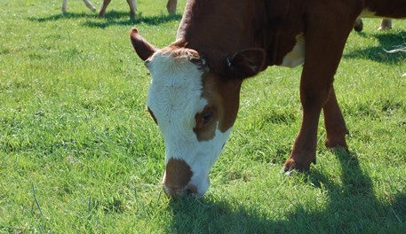
Barriers to change.
Ken Blanchard (1973) looked at 8 stages of transition people need to go through; understanding there helps us to help our teams more effectively;
Phase 1; Shock
- Feeling of numbness
- Things seem unpredictable, uncontrollable
- This is being done TO me
- ‘Why me? This isn’t what I expected? I can’t cope.’
Phase 2; Denial
- Involves a temporary retreat into the past
- ‘This can’t be happening to me!’
- Reverts to previous behaviours
- ‘Things haven’t changed really’
- ‘We used to do it this way’
Phase 3; Isolation
- ‘Leave me alone’
- People detach themselves from the situation
- People need to be left alone to devise their own coping mechanisms
Phase 4; Frustration/ Anger
- People feel frustrated and angry
- They blame others for putting them in this situation
- They feel chaotic and disorganised
- ‘I’m confused’
Phase 5; Depression
- Feeling of powerlessness; being out of control
- Lose their sense of autonomy
- Have difficulty in initiating activity
- Become re-active rather than pro-active

Phase 6; Experiments, tests new behaviours
- Start to let go of the past
- Start to accept new behaviours
- Growing sense of purpose and optimism emerges
- May try and re-invent the wheel
- Can lead to frustration if results are not immediate
Phase 7; Decisions planning
- Try and make sense of what has happened
- Try to balance the past with the new thoughts
- Re-evaluate values and career goals
- Time for quiet reflection
Phase 8; Integration/Acceptance
- Final stage of stability
- Change is integrated into experience
- Sense of direction and control
- Have developed new and effective ways of dealing with new situation

Planning the Change
The need for change can arise from either inside the organisation – to overcome problems such as complaints from customers about response times or a need to relocate premises – or outside the organisation, such as an opportunity to enter a new market, the availability of new technology or the need to respond to competitor actions. Organisations must continuously monitor the external environment and the internal situation to identify any opportunities and threats that need to be acted upon. This monitoring is sometimes done by specialist staff within the organisation – sometimes only by senior staff – but in the most successful organisations it is part of the role of all team leaders.

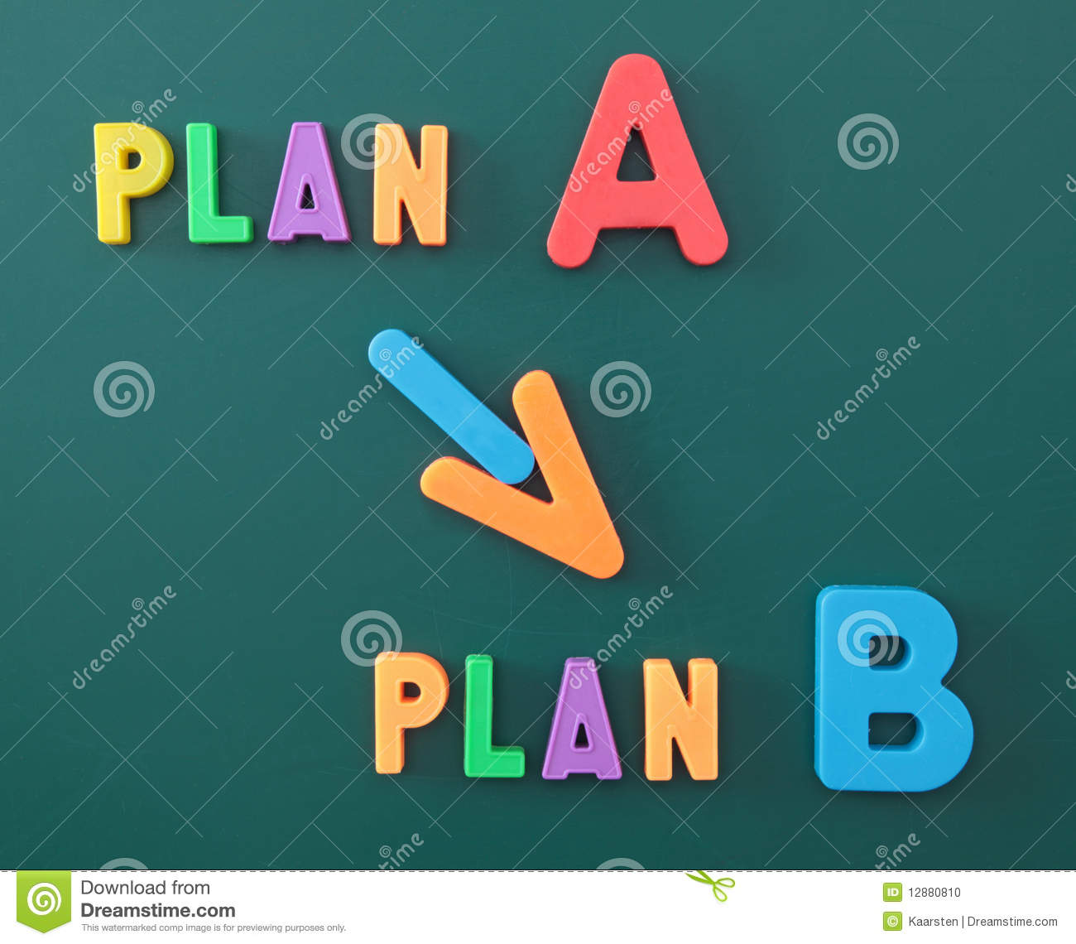

A good place to start the planning is to carry out a SWOT analysis, to candidly think about the Strengths, Weaknesses, Opportunities and Threats to your Organisation and Team. Be honest and consult as wide a range of people as possible as everyone will have different thoughts about what you do well and where there are challenges.

SWOT analysis
Fill this in honestly for your Organisation;
STRENGTHS  What are the Organisation’s strengths?  What does it do well?  What should you do more of? | WEAKNESSES  What is the Organisation not so good at?  What would you like to do less of?  Why?
OPPORTUNITIES  Where do you see the Organisation in the short/medium/longer term?  What do you think will help the Organisation to achieve this?  What other possible opportunities are there?  Markets/Products….? | THREATS  What is stopping the Organisation achieving its aims?  Why is this happening?  How can it be changed?
Think about what it tells you!
Using the SWOT analysis, list four reasons why the Organisation might need to change.
1.……………………………………………………………………………………………………………………..

………………………………………………………………………………………………………………………..

2.……………………………………………………………………………………………………………………..

………………………………………………………………………………………………………………………..

3.……………………………………………………………………………………………………………………..

………………………………………………………………………………………………………………………..

4.……………………………………………………………………………………………………………………..

………………………………………………………………………………………………………………………..

In today’s challenging economic times for farmers efficiency is key and continuous improvement (CI) should be everyone’s focus. Change Management forms an important component of CI and should be considered as part of any efficiency drive. If you did not constantly strive for CI and improved efficiency, what do you think would happen to you Organisation?
List 4 reasons to focus on CI and efficiency within your workplace.
1.……………………………………………………………………………………………………………………..

………………………………………………………………………………………………………………………..

2.……………………………………………………………………………………………………………………..

………………………………………………………………………………………………………………………..

3.……………………………………………………………………………………………………………………..

………………………………………………………………………………………………………………………..

4.……………………………………………………………………………………………………………………..

………………………………………………………………………………………………………………………..

Whilst in larger organizations a team very often leads any changes that need to happen, a strong leader is always needed; this is likely to be YOU!
Communication is the key to success. This cannot be overstated! Communicate, communicate and communicate some more!
For more information see https://ahdb.org.uk/skills/communication
If it is possible, choose a Change Management team. Think about who you would like to include in the team (as a job role rather than a named person), and which crucial area of responsibility they could be allocated. Which qualities do they need for that role?
You might need to look back at the theories of change we have already covered to help you to think this through.

Desirable qualities | Role in change management team

A change plan sets out the steps needed to achieve the change’s objectives, with clearly defined milestones, so each step can build on the momentum of the previous one. See Kotter’s Change Management model. https://www.mindtools.com/pages/article/newPPM_82.htm
To make sure everyone focuses on the required outcomes, and to provide a measure of success, the plan’s objectives should be SMART:
- Specific,
- Measurable,
- Achievable,
- Realistic,
- Time-bound.

Examples of a typical SMART goal for change might be:
Reduce the use of pesticides by 5% over the next 12 months.
Increase revenue by 3% against 2021 values for winter wheat by next harvest.

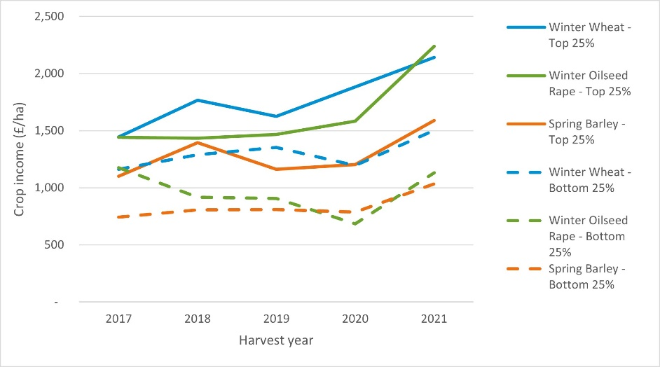

Using the SWOT analysis, you carried out previously, write 2 SMART objectives you could set for a change programme in your organisation;
1……………………………………………………………………………………………………………………..

2……………………………………………………………………………………………………………………..

What would you need in the way of resources to enable these objectives to be fulfilled?
1……………………………………………………………………………………………………………………..

2……………………………………………………………………………………………………………………..

3……………………………………………………………………………………………………………………..

Who is likely to be impacted by these changes?(think about all your stakeholders, internal and external, not just the immediate team)

1……………………………………………………………………………………………………………………..

2……………………………………………………………………………………………………………………..

3……………………………………………………………………………………………………………………..

Planning timings for activities is vital, and these are usually depicted in a chart called a Gantt chart. A simple Gantt chart is shown here.
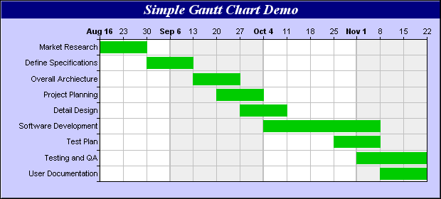

A Gantt chart details the critical steps (down the left hand side), and the timeframes along the top. Some of the steps may overlap others, but in almost every situation some things need to be achieved before others can be started; a Gantt chart gives a visual representation of what needs to happen and when, enabling everyone to see what should be happening at any given time.

Draw a Gantt chart to achieve the SMART objectives you identified earlier;

You will also need to think about setting a budget, remembering to allow an extra 10% for unexpected events and contingencies.

The outer edge of each time frame forms a critical pathway; if these events are not completed in the allocated timeframe the change will not be completed on time. Think about what can go wrong, and what contingency plan you can have in place to minimise any disruption, using examples from your Gantt chart.

Disruption to plan | Contingency plan

If communication is key, how can you ensure your team is kept fully informed of everything that is happening, which will both allay their fears and encourage them to positively embrace the change?
Think about a range of communication techniques. Does everyone have access to e-mail or read it regularly? Do you have a WhatsApp group? When can you hold face to face meetings everyone can attend? Can you use visual management techniques and put information on a white board in a staff room? The smaller the team you are dealing with, the easier this becomes. Encourage people to ask questions, voice their concerns and discuss everything with both you and each other. However, do beware of ‘Groupthink’, which is where everyone says the same and no-one likes to appear to be different. Be ‘Devil’s advocate’ and ask ‘What if…?’ type questions to encourage meaningful debate.
How can you communicate with all the members of your team so that they feel involved with the change process?

1……………………………………………………………………………………………………………………..

2……………………………………………………………………………………………………………………..

3……………………………………………………………………………………………………………………..

Think about the barriers the staff may raise that you will need to overcome in a motivational way. Also see https://ahdb.org.uk/engaging-your-staff
What sort of obstacles do you think team members may raise?
1……………………………………………………………………………………………………………………..

2……………………………………………………………………………………………………………………..

3……………………………………………………………………………………………………………………..

How can you overcome them?
1……………………………………………………………………………………………………………………..

2……………………………………………………………………………………………………………………..

3……………………………………………………………………………………………………………………..

Implementing the Change
Having planned the process and timeframes on your Gantt chart (as much as possible of which should be done before the change project starts), the next stage is the actual implementation. Whilst ongoing communication is still vital, monitoring and evaluating process is now a critical part of your role.
Costs against budget is always an important area to consider, as well as thinking about how the resource planning is working out in reality. Are any unforeseen events happening which might de-rail your plans (a typical example is an unexpected weather event), and how do you mitigate their effects?
What do you think you will need to monitor carefully; what will you do about it if it threatens to de-rail your plans?

Unforeseen event | Mitigating activity

It is also important to have a plan as to HOW you are going to carry out your monitoring activity. This is generally carried out by direct observation, communication with your team and analysis of data Think about the advantages and disadvantages of the different monitoring activities you could carry out;

Monitoring activity | Advantages | Disadvantages

Remember to look back to your timescales on your Gantt chart to check everything is happening in a timely fashion. You may have to implement contingency plans if there are unexpected delays which might jeopardise the success of the change and meeting the objectives.
It is essential you set small milestones which can be celebrated to encourage ongoing participation in the change. Include as many of your stakeholders as possible in both your communications and your celebrations!
Looking at the Gantt chart you prepared earlier, what are the milestones you could celebrate. How can you celebrate them in an appropriate, motivational, encouraging manner?

Planned milestone | Suitable celebration

Unfortunately, rarely does a change management project go totally smoothly from start to finish, so it is also important you understand who among your stakeholders you need to notify if there are challenges along the way. Think of some realistic scenarios you may have to deal with;

Challenge | Who needs to know?
How do you evaluate success?
By seeking feedback from all the stakeholders involved, including your team, you can start to evaluate whether the change has been successful. Remember to seek objective quantitative feedback, from your data sets, which might be financial information for example, and qualitative feedback, which is much more subjective. Both are relevant to the declaration of success, and both can help you to ascertain that your objectives are being met.
This feedback can be collected informally, by talking to stakeholders, your own observations and asking key players, or it could be a more formal process. More formal processes can include questionnaires, facilitated discussion groups, or online feedback (for example if customers are involved) and may be carried out by a third party rather than yourself if you choose. If asking questions to be rated, give an even number of choices, such as Agree Strongly, Agree, Disagree, Disagree strongly, so that there isn’t an option to Neither agree or disagree, which doesn’t actually tell you anything!
How will you gather feedback from your team?

Method | Advantage | Disadvantage

From your stakeholders?

Method | Advantages | Disadvantages

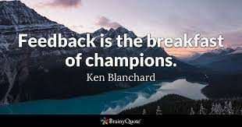

It is important that the feedback is accurately collated and viewed as a whole data set, as taking answers in isolation may give you a false impression of the success or failure of the change. A farm shop, for example, might have carried out a change which was very popular with the customers, but highly unpopular with the staff, and this feedback needs to be both understood and used to inform ongoing decision making.
Think about how you can meaningfully utilise the feedback you have collected, and use it to inform future decision making.

As mentioned earlier in this workbook, continuous improvement is necessary for any organisation to move forward. Thinking of Deming’s Cycle.
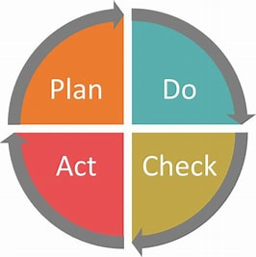

You are in the position to check how well the change has worked or adjust further or start planning for the next change! Always have a de-brief meeting to see what lessons have been learnt, what you could do differently in future, what went well, even better if!
Fill in the table.
Lessons learnt.

Things to do differently.

What went well.

Even better if.

Bear the answers in mind as you plan your next change management project, and remember change is a series of processes from
Unconscious incompetence to
Conscious incompetence to
Conscious competence to
Unconscious competence as people become accustomed to the change.
Good luck!
Further research for you
Why Is Change So Hard?. Futurist Alvin Toffler said, “Change is… | by Brent Reynolds | Medium
Leading Organizational Change Program | The Ken Blanchard Companies
Kotter’s Change Management Model Process Checklist | Process Street
The Kubler Ross Change Curve: Understanding The 5 Stages Of Change (themindsjournal.com)
Transforming the Organization Through Data and Analytics – Dealing With ‘Messy’ Change | OPINION | cdomagazine.tech
https://ahdb.org.uk/knowledge-library/the-leader September ‘22 edition and others
Listen
How to get people on board with your great ideas
You have an innovative idea for your business or a solution to a problem. That’s great! So why are people so resistant to getting on board with it? In this podcast, Loran Nordgren and David Schonthal explore the sticking points that make people less likely to adopt change.
Listen to the podcast

Watch
Be more pirate – in conversation with Sam Conniff
Sam Conniff is the bestselling author of Be More Pirate and the creator of The Uncertainty Experts, an interactive, three-part documentary proven to reduce fear of the unknown, reduce anxiety, increase empathy and improve decision-making and problem-solving. In this interview, Sam discusses the importance of challenging the norms and speaking your mind.
Watch the interview

Read
Emotional intuition for peak performance
With a blend of science, theory, and Eastern thought, Emotional Intuition for Peak Performance lays the groundwork to help you live a satisfying and meaningful life. This book will help you discover, understand and implement the strategies and skills you need to achieve the best possible you.
Find out more and buy the book

